**Lab report no 9**



**Fall 2022**

**CSE-308L Digital Systems Design Lab**

**Submitted By**

**Names Registration No**

# Muhammad Ali 19pwcse1801

Section: **A**

**Date**:24,jun,22

**Submitted To: MAM. Madiha Sher**

Department of Computer Systems Engineering

University of Engineering and Technology, Peshawar

**Implement Traffic Light Controller using FSM.**

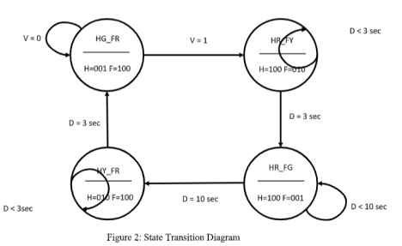

**Task code: -**

module Traffic_lights(clk,rst,v,out_farm,out_highway);

input clk,rst,v;

output reg [2:0] out_farm, out_highway;

reg [1:0] PS,NS;

parameter [1:0] FR_HG = 0, FY_HR = 1, FG_HR = 2, FR_HY = 3;

parameter [2:0] red = 100, yellow = 010, green = 001;

wire out_clk;

clk_divider d1(clk,out_clk,rst);

always @(posedge out_clk)

if(rst==0)

begin

PS = FR_HG;

end

else

PS = NS;

always @(PS or v or rst)

case(PS)

FR_HG:

begin

NS = v?FY_HR: FR_HG;

out_highway = v?red:green;

out_farm = v?yellow:red;

end

FY_HR:

begin

NS = FG_HR;

out_highway = red;

out_farm = green;

end

FG_HR:

begin

NS = FR_HY;

out_highway = yellow;

out_farm = red;

end

FR_HY:

begin

NS = FR_HG;

out_highway = green;

out_farm = red;

end

endcase

endmodule

**clock divider: -**

module clk_divider(input in_clk,output reg out_clk, input rst);

reg [100:0] count;

always @(posedge in_clk)

if(rst==0)

begin

out_clk = 0;

count = 0;

end

else

begin

count = count+1;

if(count==3*100000000)

begin

out_clk = ~out_clk;

count = 0;

end

end

endmodule

**UCF file:**

net "rst" LOC =K18 | IOSTANDARD = LVCMOS33 | DRIVE = 8 | SLEW = FAST | PULLUP; net "v" LOC =F17 | IOSTANDARD = LVCMOS33 | DRIVE = 8 | SLEW = FAST | PULLUP; net "clk" LOC =V10 | IOSTANDARD = LVCMOS33 | period = 100MHz;

net "out_highway[0]" LOC = N16 | IOSTANDARD = LVCMOS33 | DRIVE = 8 | SLEW = FAST; net "out_highway[1]" LOC = U17 | IOSTANDARD = LVCMOS33 | DRIVE = 8 | SLEW = FAST; net "out_highway[2]" LOC = U18 | IOSTANDARD = LVCMOS33 | DRIVE = 8 | SLEW = FAST; net "out_farm[0]" LOC = P15 | IOSTANDARD = LVCMOS33 | DRIVE = 8 | SLEW = FAST;

net "out_farm[1]" LOC = P16 | IOSTANDARD = LVCMOS33 | DRIVE = 8 | SLEW = FAST; net "out_farm[2]" LOC = N15 | IOSTANDARD = LVCMOS33 | DRIVE = 8 | SLEW = FAST;